**LAB EXPERIMENTS** DAY-1

**1.AIM:-**To implement UML diagrams for passport management system..

**DESIGN:-**

1.USE CASE:

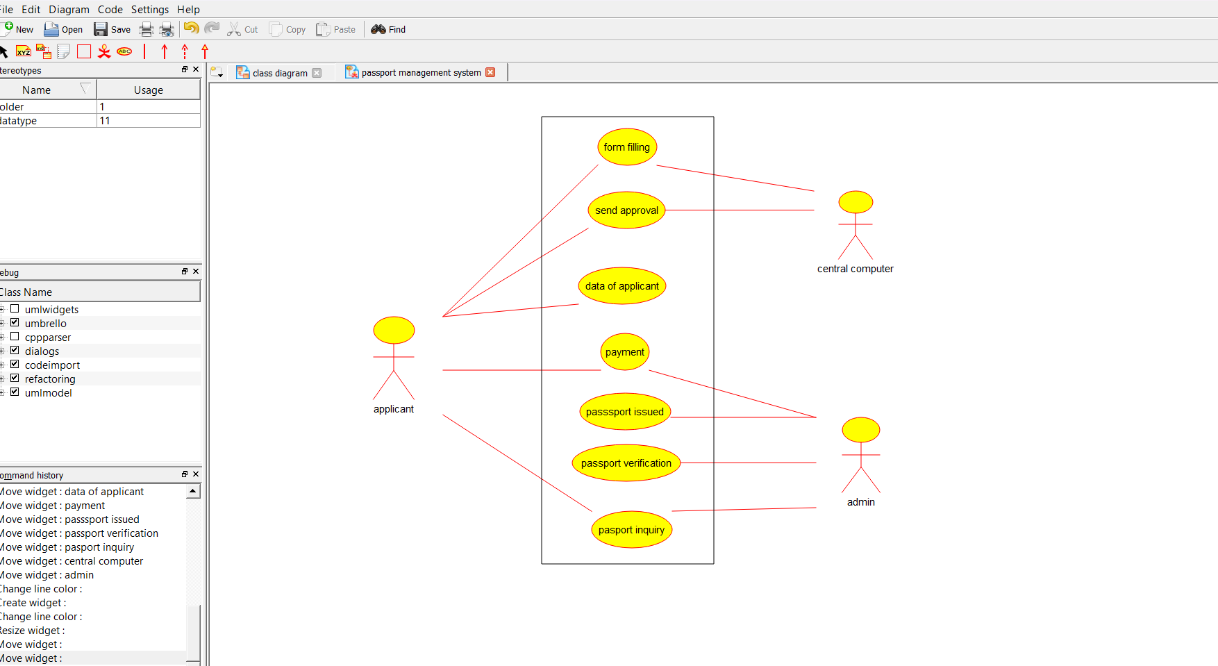

2.CLASS DIAGRAM:-

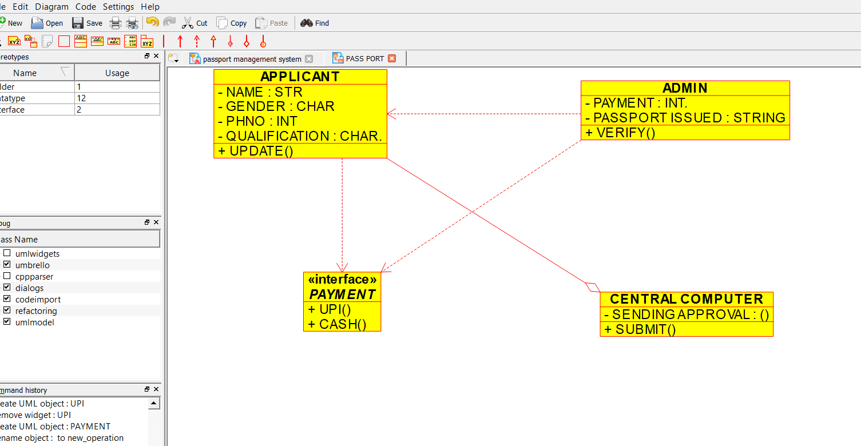

SEQUENCE DIAGRAM:-

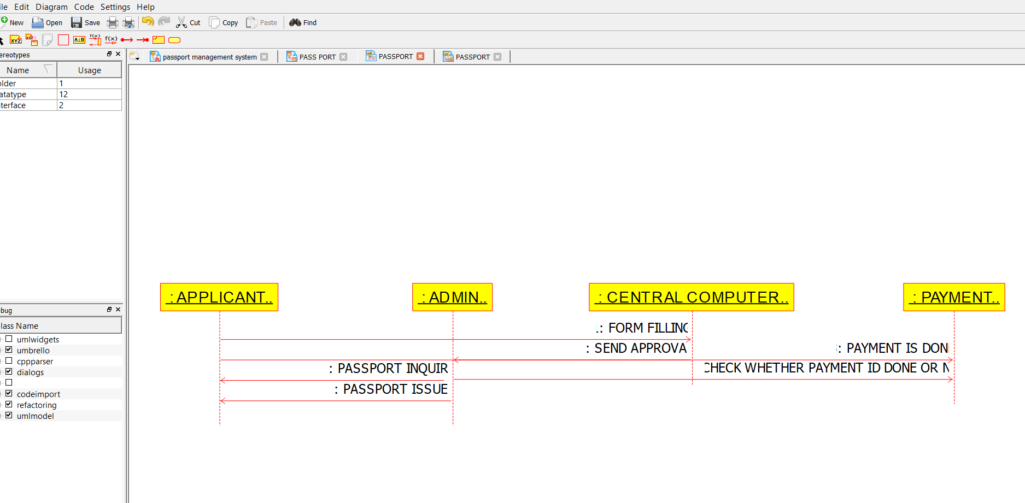

PACKAGE DIAGRAM:-

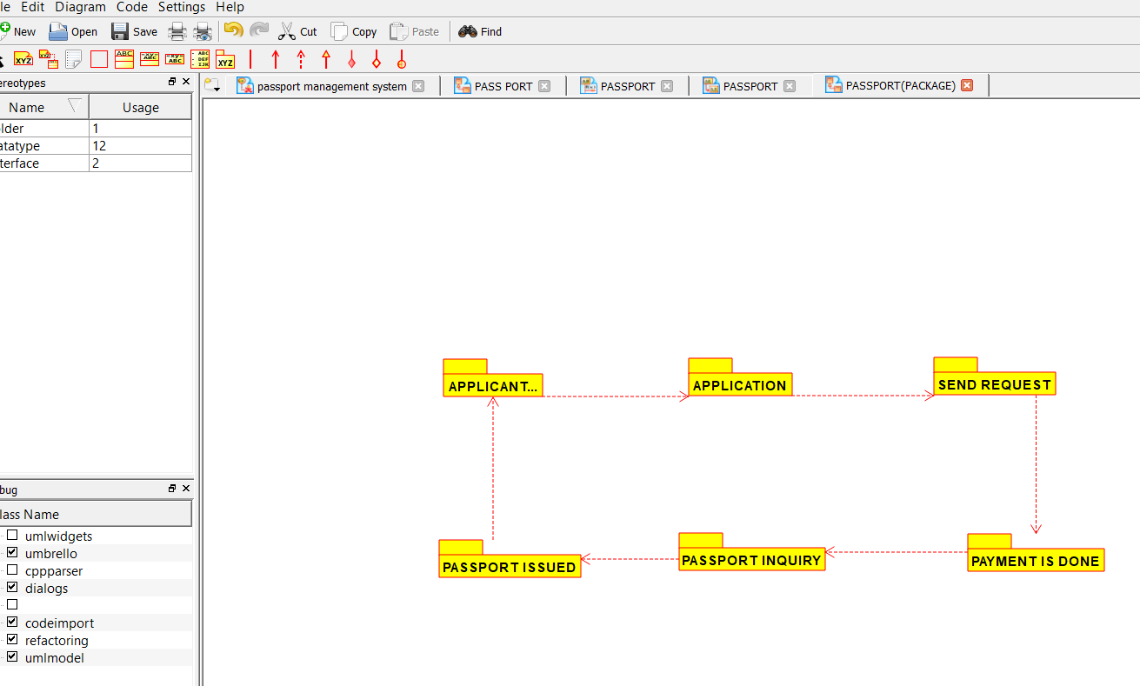

**2.AIM:-**To implement UML diagrams for BANK BOOK PROCESS ..

**DESIGN:-**

1.USE CASE:

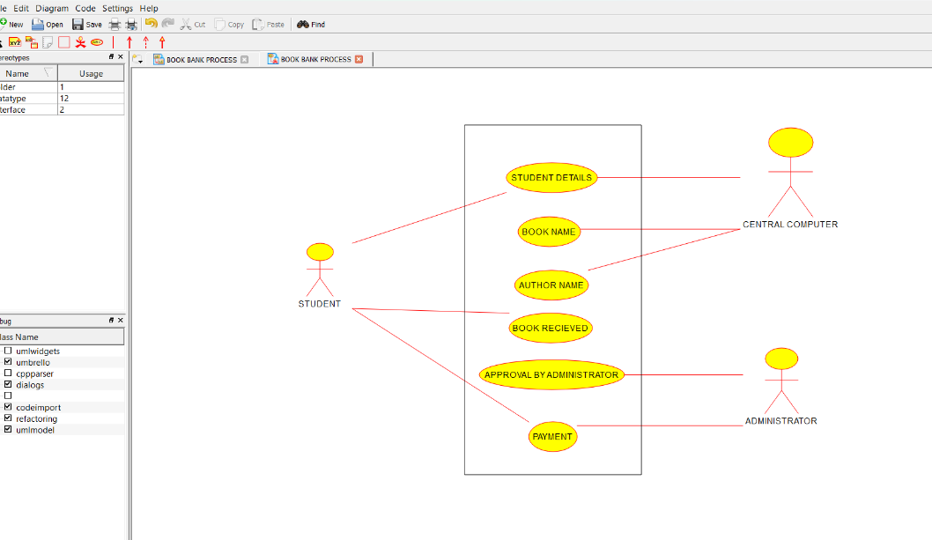

2.COLLABORATION DIAGRAM:-

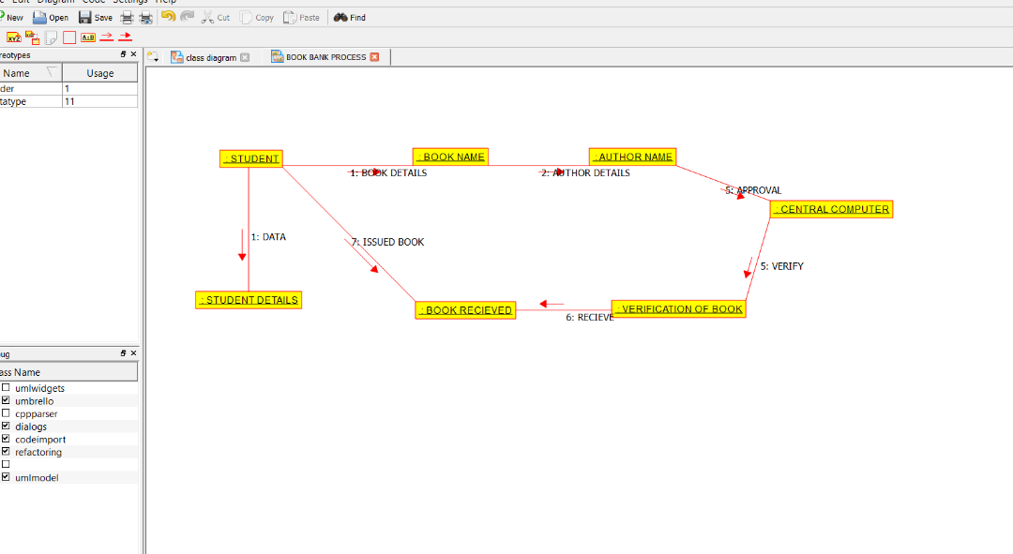

3.DEPLOYMENT DIAGRAM:-

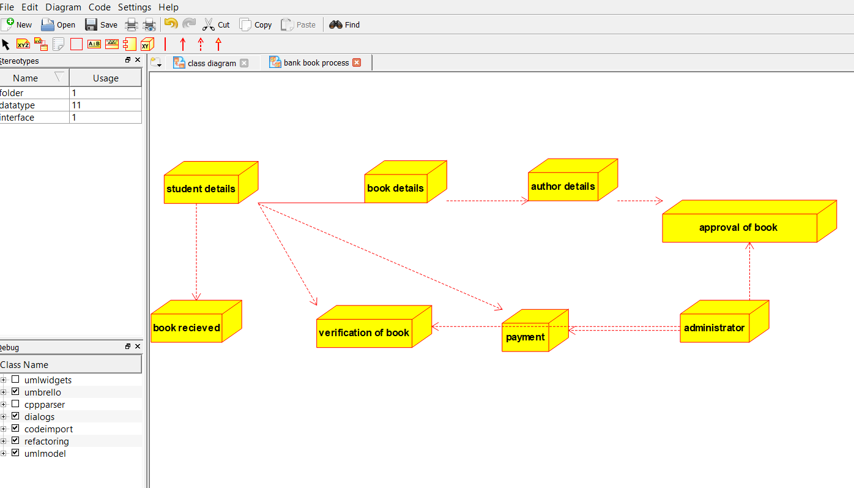

**3.AIM:-**To implement UML diagrams for EXAM REGISTRATION PORTAL…

**DESIGN:-**

1.COMPONENT DIAGRAM:

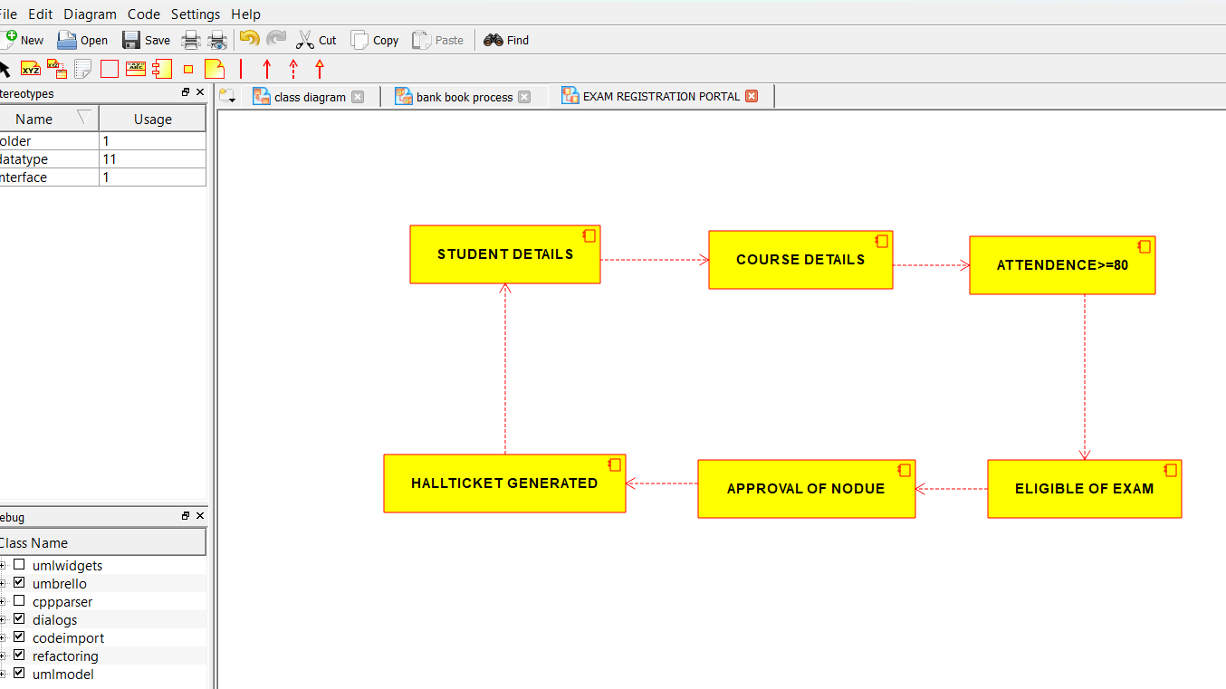

2.PACKAGE DIAGRAM:-

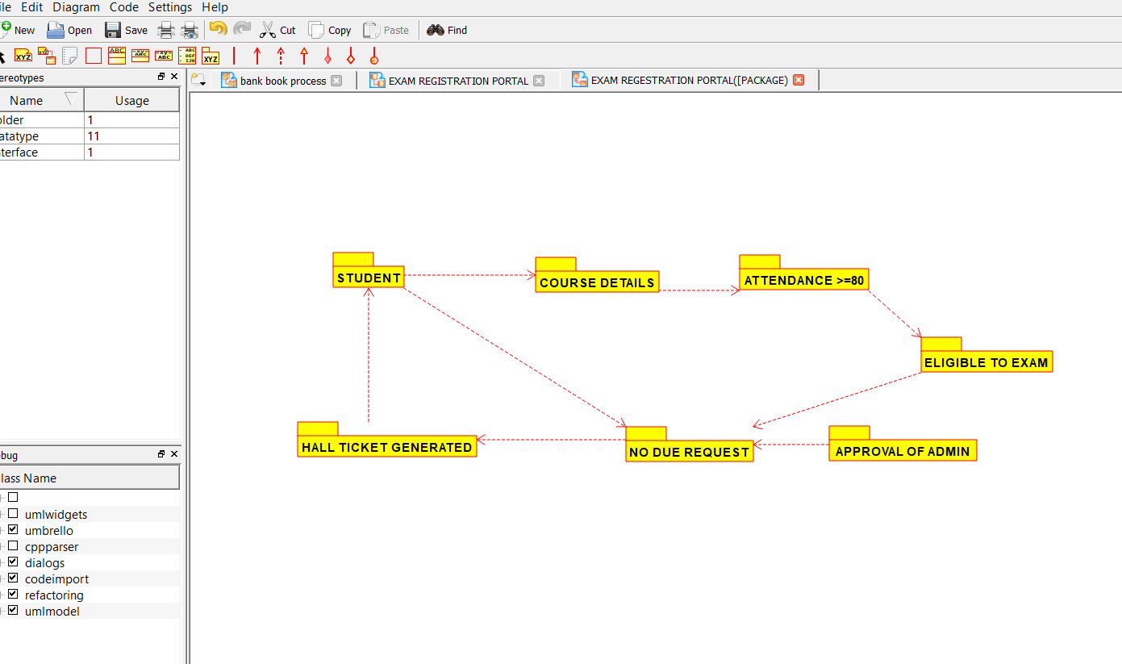

3.USECASE DIAGRAM:-

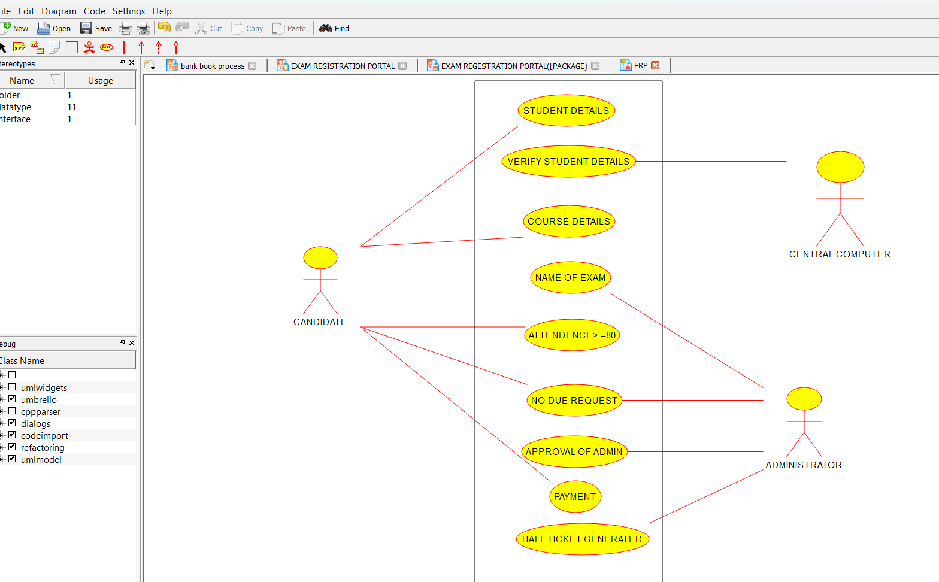

**4.AIM:-**To implement UML diagrams for STOCK MAINTAINANCE SYSTEM…

**DESIGN:-**

1.STATECHART DIAGRAM:-

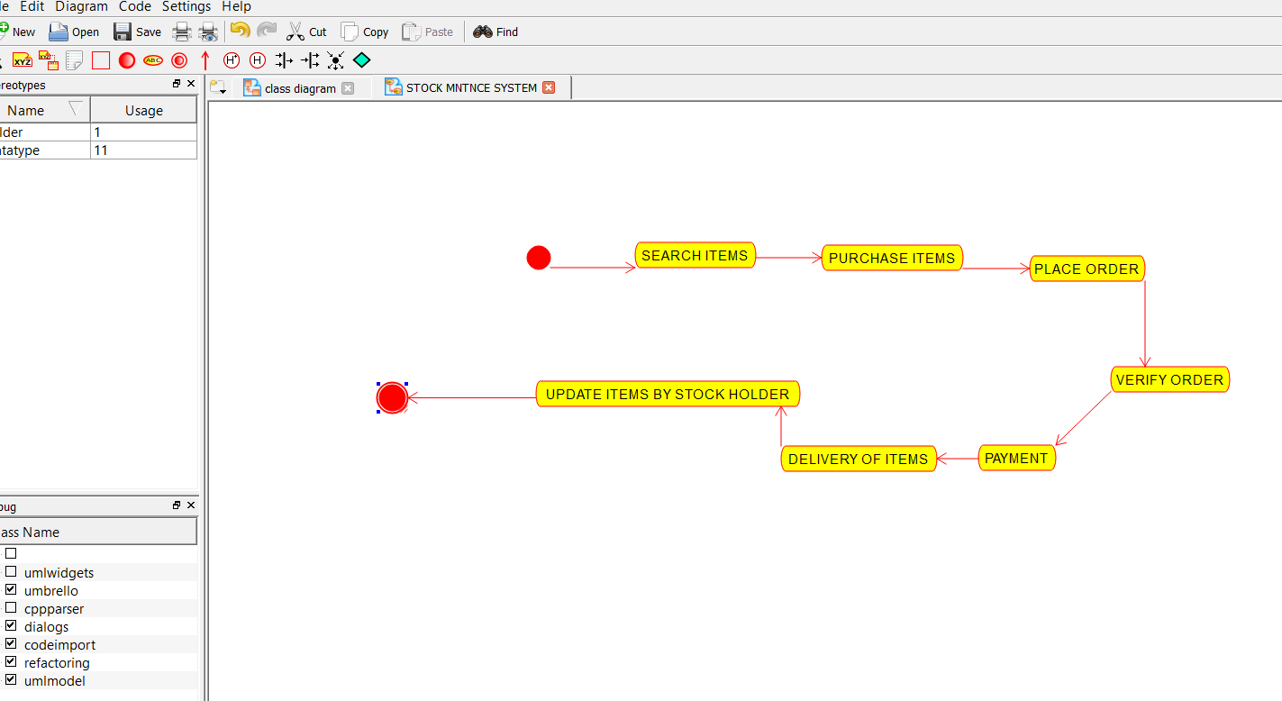

2.DEPLOYMENT DIAGRAM:-

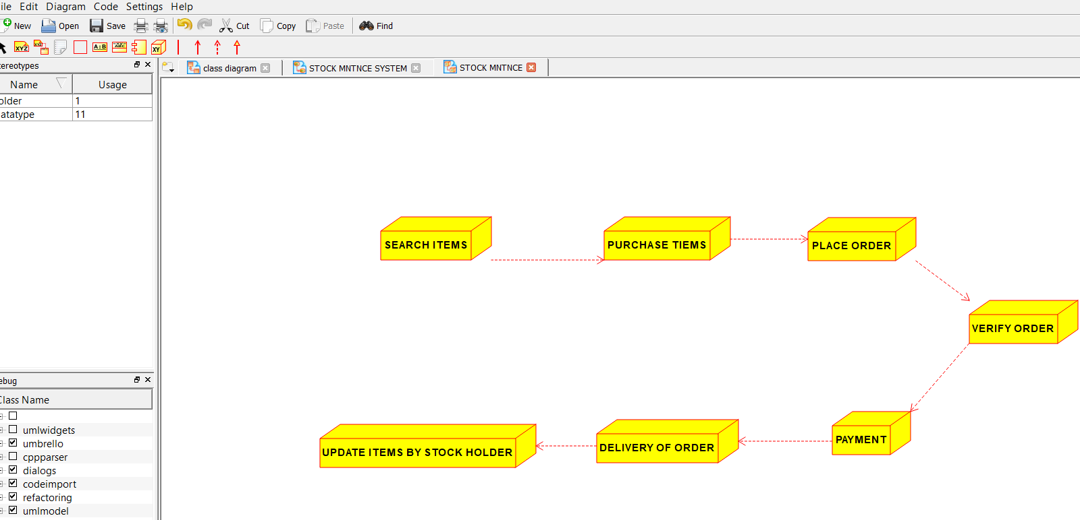

3.PACKAGE DIAGRAM:-

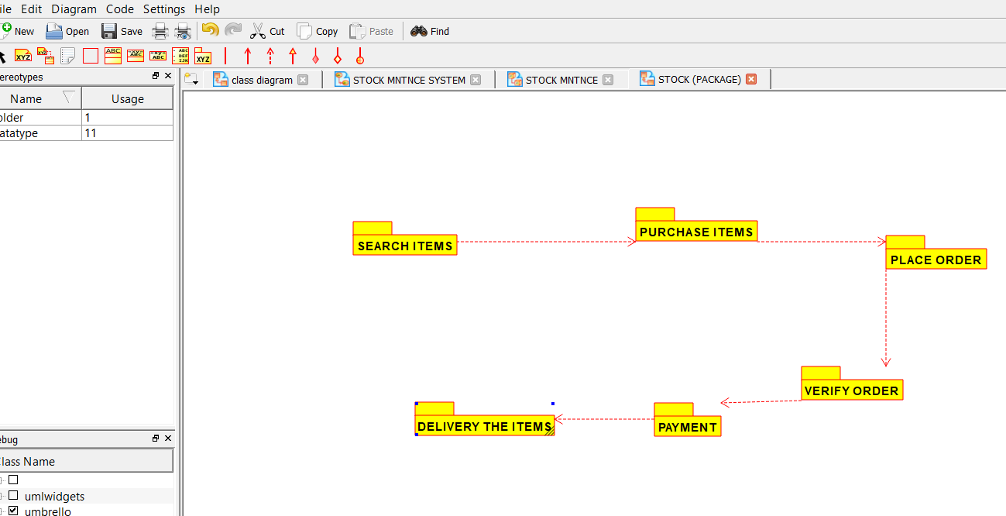

**5.AIM:-**To implement UML diagrams for ONLINE COURSE RESERVATION SYSTEM…

**DESIGN:-**

1.COLLABORATION DIAGRAM:-

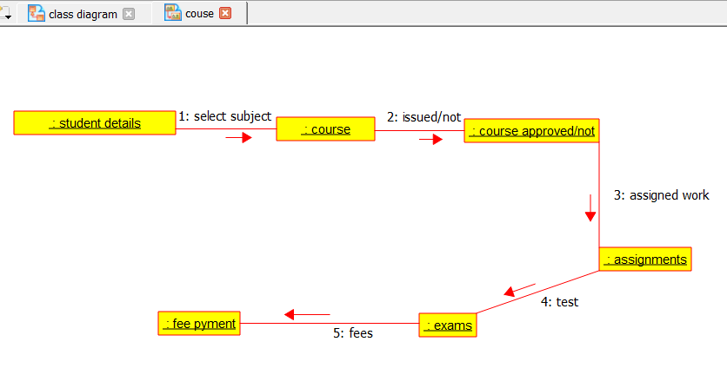

2.USECASE DIAGRAM:-

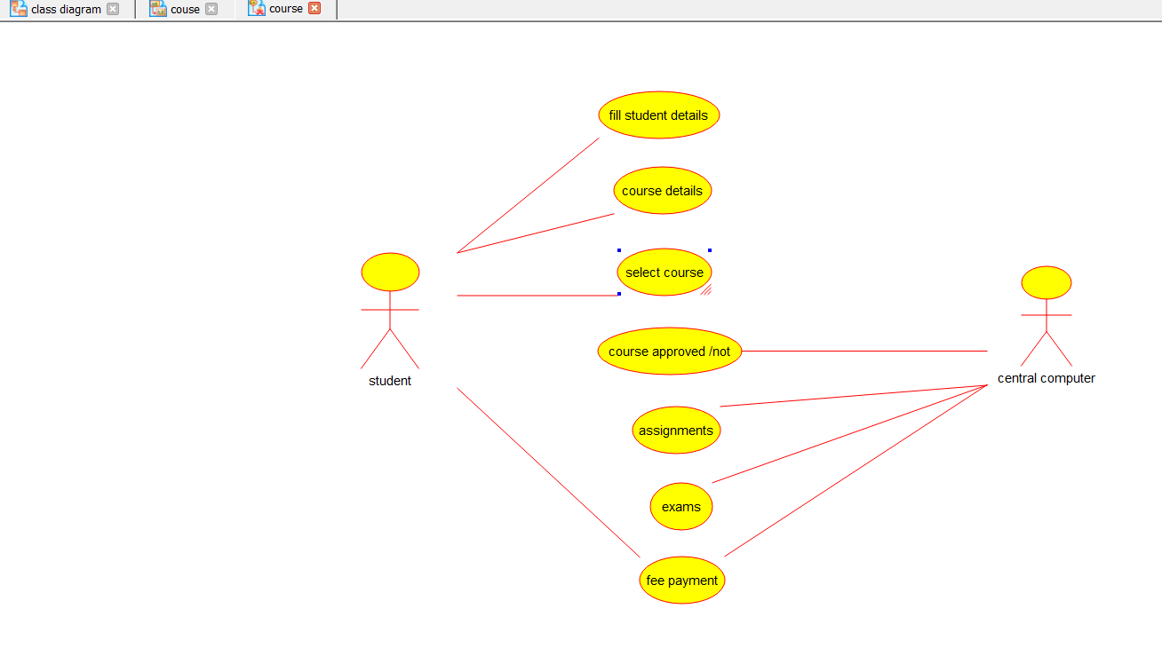

**6.AIM:-**To implement UML diagrams for E-TICKETING SYSTEM…

**DESIGN:-**

1.ACTIVITY DIAGRAM:-

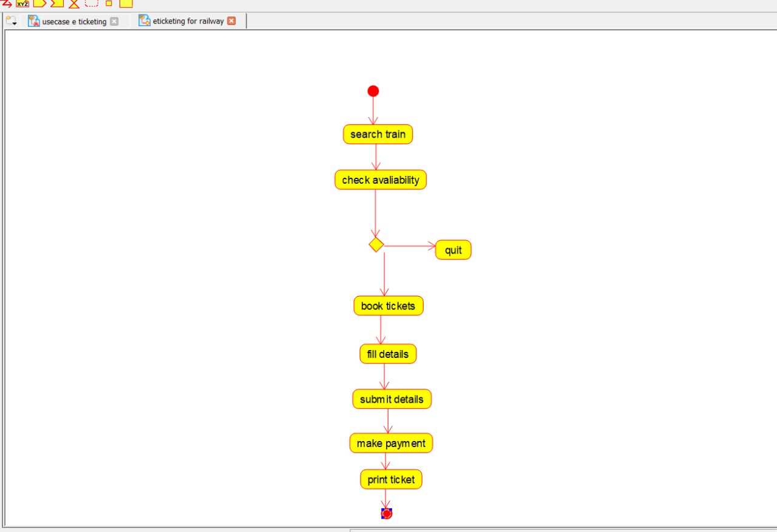

2.USECASE DIAGRAM:-

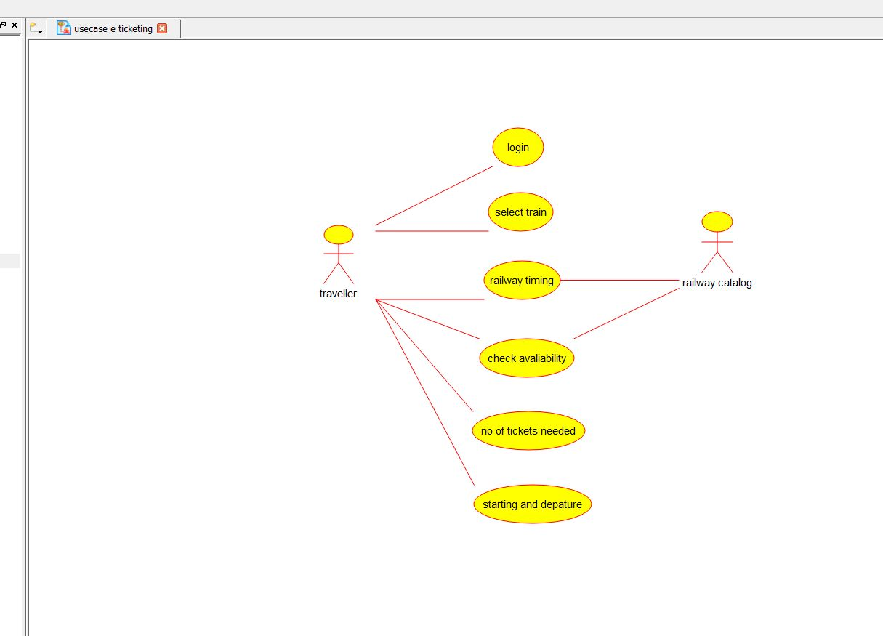

3.COMPONENT DIAGRAM:-

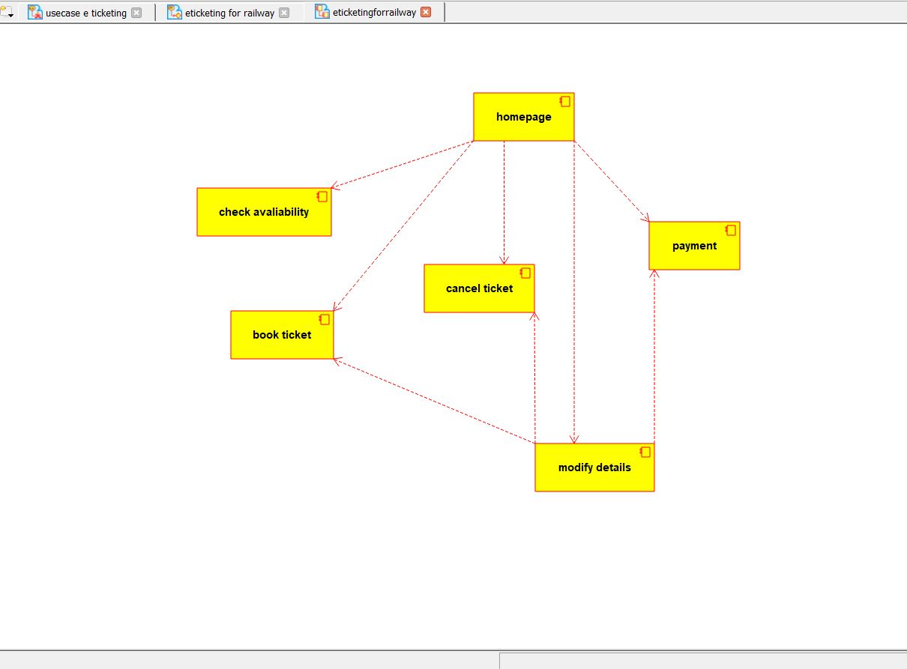

**7.AIM:-**To implement UML diagrams for CREDIT CARD PROCESSING SYSTEM…

**DESIGN:-**

1.ACTIVITY DIAGRAM:-

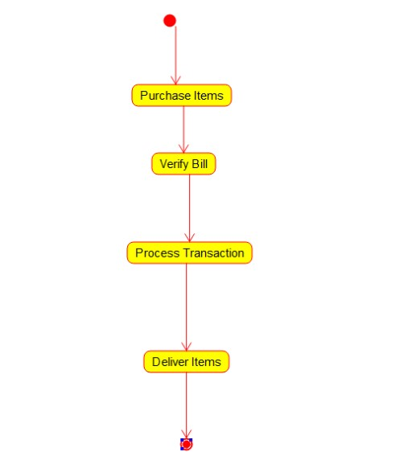

2.CLASS DIAGRAM:-

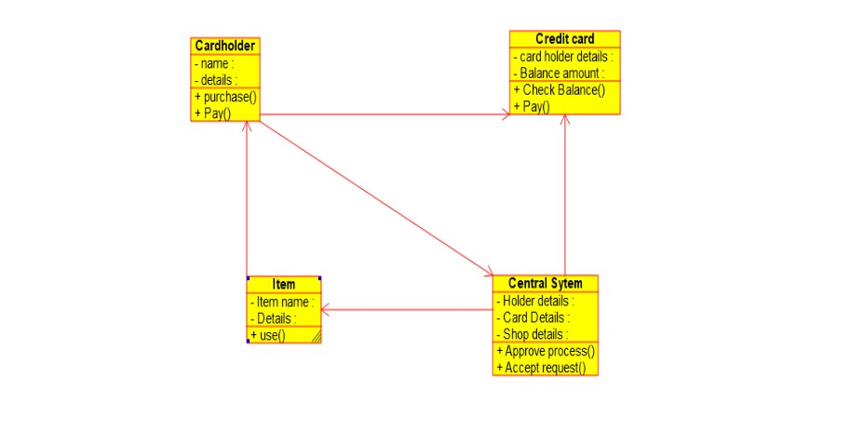

3.COMPONENT DIAGRAM:-

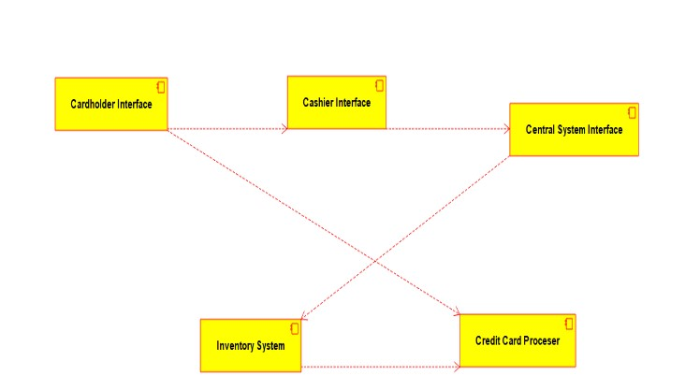

**9.AIM:-**To implement UML diagrams for E-BOOK MANAGEMENT SYSTEM…

**DESIGN:-**

1.USECASE DIAGRAM:-

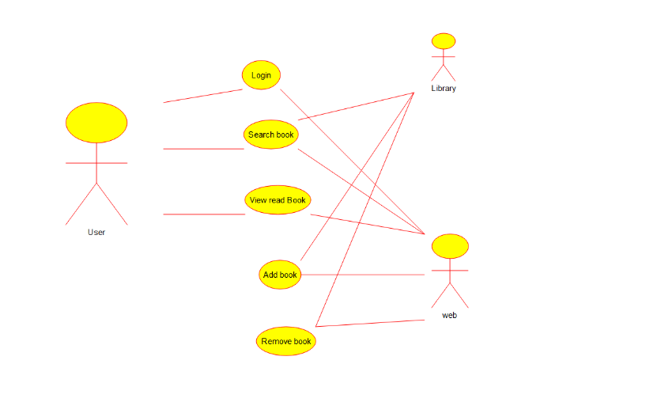

2.CLASS DIAGRAM:-

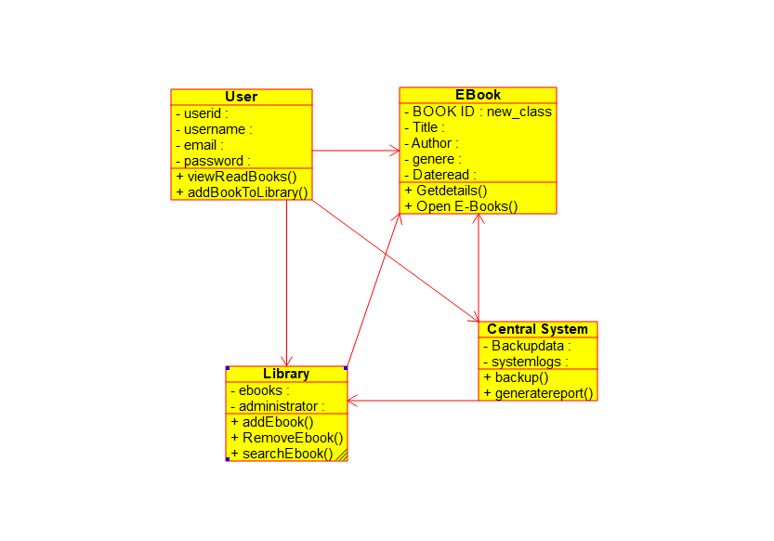

3.ACTIVITY DIAGRAM:-

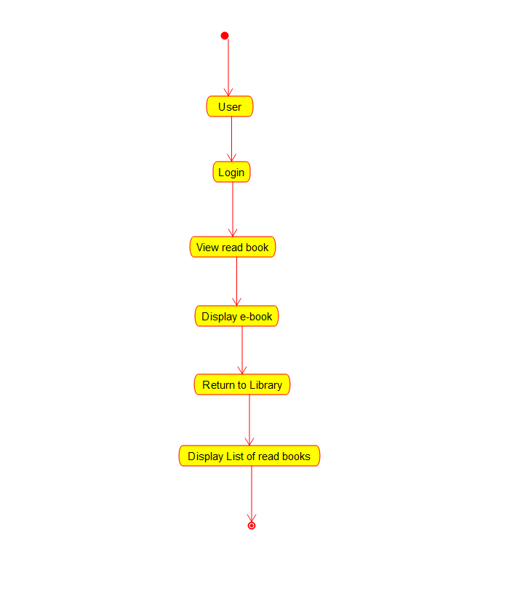

3.CLASS DIAGRAM:-

